**Irzem Ahmed**

[Lutou Xiong](mailto:lxiong13@uncc.edu)

[Andrew Schulz](mailto:aschulz6@uncc.edu)

**Kevin Salley**

**Initial Product Backlog**

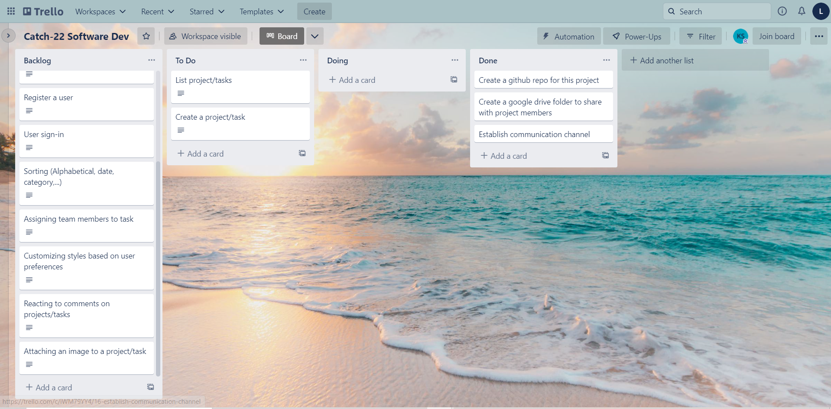

User stories are listed in description of cards

<https://trello.com/b/YDzMUAZ5/catch-22-software-dev>